Technical paper msword template and submission guidelines

R.J. Bathurst, GeoEngineering Centre at Queen’s-RMC, Royal Military College, Kingston, Canada

E.M. Palmeira, Department of Civil and Environmental Engineering-FT, University of Brasilia, Brasilia, Brazil

Denys Parra, Anddes Asociados, Lima, Peru.

ABSTRACT

Papers must be written in English or Spanish and must be based on an accepted abstract. Once the corresponding author has been notified that the abstract has been accepted the first draft manuscript must be submitted by  **October 6th, 2019** using the conference website at <https://www.geoamericas2020.com>. The manuscript must be prepared using this MSWord template and in accordance with the instructions contained herein. The draft manuscript will be reviewed for suitability as a contribution to the conference proceedings and for oral presentation. Authors may be required to make revisions and submit the final paper by **January 26th, 2020**. At least one author of each paper must be registered as a full conference delegate (or student, if applicable) in order to submit a final manuscript using the conference web site. Papers submitted to the conference organizers in any other way will not be accepted. The abstract must not exceed 250 words. In the event of a conflict between this document and the example paper this document will govern.

RESUMEN

An optional abstract in Spanish “RESUMEN” or Portuguese “RESUMO” may follow the English abstract or an English “ABSTRACT” or Portuguese “RESUMO” may follow the Spanish “RESUMEN”. This optional abstract must not exceed 150 words.

# introduction

## *Publication Quality and Uniformity*

To ensure publication quality and uniformity, the following guidelines are intended to assist authors in preparing their papers for the conference. Authors of papers are encouraged to type their manuscript into this template to ensure uniformity of paper presentation in the conference proceedings. A document titled **Guidelines for Technical Papers** can also be downloaded from the conference web site at <https://www.geoamericas2020.com>.

If these guidelines are not followed, your paper will be returned to you for revision and re-submittal. The resulting time delay could lead to your paper not being published in the conference proceedings due to printing deadlines.

## *Required Registration*

The presenting author must register as a full conference delegate (or student if applicable) in order to submit a final paper. This must be done online through the conference web site at <https://www.geoamericas2020.com>

## *Online Submission*

All draft and final papers must be submitted electronically in PDF format using the online submission feature on the conference web site. Your draft manuscript must be received by **October 6th, 2019** and your final manuscript by  **January 26th, 2020**. Papers submitted to the conference organizers in any other way will not be accepted.

For further information on manuscript submission using the online web site please visit the conference web site at: <https://www.geoamericas2020.com>.

## *Important Paper Deadlines*

* **October 6th, 2019** - First draft papers due
* **December 15th, 2019** - Authors notified of paper review results.
* **January 26th, 2020** - Final revised papers due

# formatting details

## *Length*

The length of a complete paper including title, abstracts, text, figures, photographs, tables, acknowledgments and references is **FOUR (4) to TEN (10) pages**. Papers will not be accepted if they are longer than ten (10) pages. These papers will be reprinted in their original format.

## *Font*

All text must be 9 point Arial font with the following exceptions:

* The title must be 14 point Arial font (bold);
* The author name(s), affiliation, city, and country must be 10 point Arial font.

## *Page Size and Margins*

Select 210 × 297 millimeters (8.27 × 11.69 inches) A4 format size and use the following page dimensions: top margin = 25 mm, bottom margin = 25 mm, left margin = 25 mm, right margin = 25 mm, and gutter width = 6 mm.

## *Page Numbers*

Do not insert page numbers or headers or footers. These will be added when the proceedings are assembled.

## *Spacing and Indenting*

All text elements should be single-spaced. Text must be in one (1) column. No indents should be used anywhere, except in the references.

One (1) open line should be left between paragraphs. The text should be right and left justified.

Leave two (2) open lines above and one (1) open line beneath primary headings - leave one (1) open line above and one (1) open line beneath secondary and tertiary headings. Leave one (1) open line between equations and text, and between successive equations. Leave one (1) open line between the body of text and figures or tables (including captions).

## *Title/Author(s)*

The full paper title should be typed at the top of the first page in 14 point Arial font, bold and uppercase, and left justified.

Leave one (1) open line at 10 point font following the title.

The author name(s), affiliation and country should then be typed in 10 point Arial font. Do not use italics. Do not include author titles. Include initials only for first and middle names.

## *Abstracts*

Each paper must begin with an abstract in English or Spanish with no more than 150 words in total.

For the abstract in English, type the word "ABSTRACT" and then the English abstract. Leave one (1) open line and repeat with the Spanish or Portuguese version of the abstract preceded by the word “RESUMEN” or "RESUMO", respectively. A Spanish or Portuguese abstract is optional.

For the abstract in Spanish, type the word "RESUMEN" and then the Spanish abstract. Leave one (1) open line and repeat with the English or Portuguese version of the abstract preceded by the word “ABSTRACT” or "RESUMO", respectively. An English or Portuguese abstract is optional.

Leave three (3) open lines (9 point font) between the preceding author block and between the last abstract and the body of the text.

## *Number Headings*

Within the paper, number all headings as follows:

1. PRIMARY HEADING

1.1 *Secondary Heading*

* + 1. *Tertiary Heading*

Avoid orphan headings.

## *Spelling*

Spelling is to conform to customary US usage, as given in Webster's or Random House Unabridged Dictionaries. For Spanish papers spelling is to conform to customary Latin American usage.

## *Equations, Formulas, Symbols and Units*

Type and center equations and formulas on the page. Leave one (1) open line above and below the equation.

Equation numbers must be placed flush at the right margin in square brackets and numbered consecutively.

Refer to equations in the body of the text by these numbers (e.g., "Eq.1" or "Equation 1 shows..."). Symbols and notations should conform to those recommended by the International Geosynthetics Society in the following document

<http://www.geosyntheticssociety.org/Resources/Documents/Recommended%20Mathematical%20and%20Graphical%20Symbols.pdf>

Use SI units and Arabic numbers, and do not use italics.

Example of equation:

⧫ =  tan   c [1]

## *Tables*

Number tables consecutively in order of appearance and locate them close to the first reference to them in the text. Refer to tables as Table 1, or Tables 1 and 2, in the body of the text. Avoid abbreviations in column headings (other than units).

Center and type the caption above the table to the same width as the table, and leave one (1) open line between the table caption and the table and between the table caption and the preceding text. Leave one (1) open line between the table and following text. Center the table on the page.

Use the following example for the format of table.

Table 1. Characteristics of tested soils.

|  |  |  |
| --- | --- | --- |
| Characteristics | Vancouver | Richmond |
| Organic matter (%) | 0 | 1 |
| Water content (%)1 | 40 | 60 |
| Liquid limit (%) | 22 | 44 |
| Plastic limit (%) | 15 | 18 |
| Sand (%) | 35 | 8 |
| Silt (%) | 45 | 44 |
| Clay (%) | 20 | 48 |

1water content of specimens after preparation for testing

## *Illustrations and Figures*

All illustrations must be embedded in the MS Word document using Edit 🡪 Paste Special 🡪 Picture.

Center the illustration or figure on the page. It is permissible to have two illustrations or figures side by side provided they are legible. Leave one (1) open line before and after the illustration or figure.

Please number illustrations (whether drawings or photographs) consecutively in the order of appearance and refer to them as Figure 1, Figures 2 to 4, etc.

Do not place illustrations sideways on a page; however, if this cannot be avoided, no other text should appear on that page.

Drawings may be in color but authors should select colors that are effective when reproduced in black and white hardcopy.

Photographs may be in color but authors should note that the printed proceedings will be in black and white.

Lettering should be approximately the same size as the text with a minimum height of 2 mm. Lines should preferably be 0.2 mm thick. Captions should be placed immediately below the illustration and centered on the page.

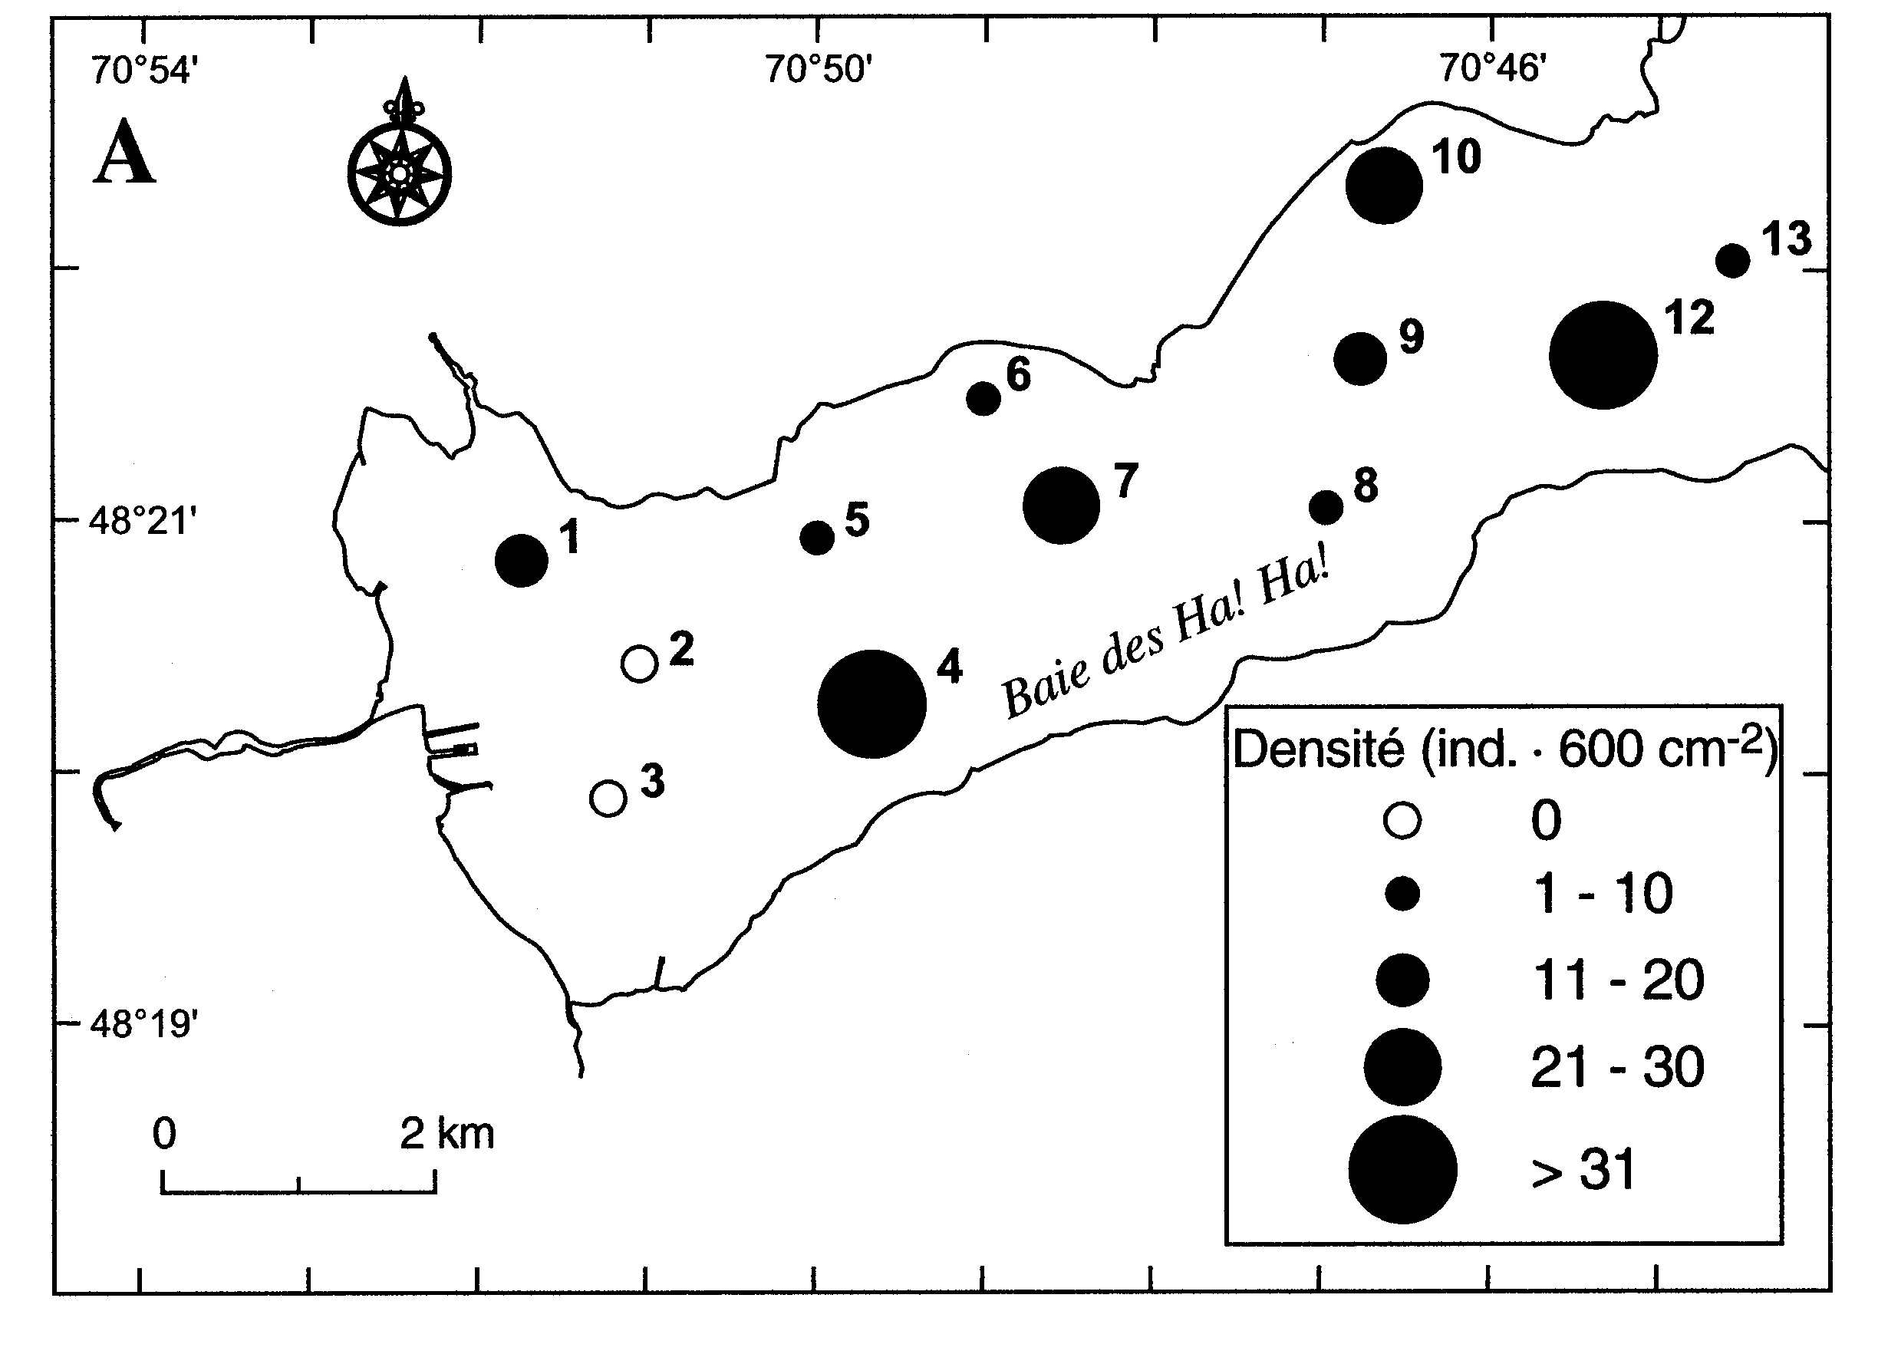

Figure 1. Spatial distribution of the macro-benthic organisms (from Pelletier et al. 1999).



a) PP reinforcement b) WWM reinforcement

Figure 2. Wall deformations.

# Clearances and copyright material

Authors are responsible for obtaining written permission to profile the project or subject matter in their papers from any and all clients, owners or others who contracted for the work.

If a figure, table or photograph was previously published, the author must obtain written approval from the original publisher before it can be reprinted in the conference proceedings.

The conference organizers assume that you have obtained the proper permission(s) as applicable. The conference organizers assume no liability for failure by the authors to gain proper permissions.

The source of previously published material should be included in the caption of the table, figure or photograph.

# Commercialism

All commercialism must be avoided. Papers may not include any promotion for products, services, or companies. Company logos shall not appear anywhere in the paper. Authors shall not use brand names or company names in the paper titles. When a brand name must be used in a paper, the brand name may appear only once in the text of the paper and then be referred to thereafter by a generic description. No brand name may appear in any table, figure or picture. The authors of a paper should be identified by their name, affiliation, and country. Any violation of these rules will result in automatic rejection of the paper for presentation and publication in the conference proceedings.

# ACKNOWLEDGEMENTS

Providing an acknowledgment of sponsorship at the end of a paper is permitted. The acknowledgements heading should appear without a heading number. The ACKNOWLEDGEMENTS section should follow the text of the paper and precede the REFERENCES section.

## REFERENCES

The REFERENCES heading should appear without a heading number.

Within the body of the text, references should be made in parenthesis with the author’s surname(s) and the year of publication such as “(Seed et al. 1977)” or “According to Seed et al. (1977)…”

At the end of the paper, list all references in alphabetical order of authors’ names. The first line of each entry in the reference list should not be indented: the following lines should have 5 mm indention. Do not leave an open line between references. Type book titles and the names of journals, reports and conferences, etc. In *italics.*

Format for books is: last name, initials (year) *Book Title,* Publisher, City, State/Province, Country (of publisher). For example:

Terzaghi, K. and Peck, R.B. (1987). *Soil Mechanics in Engineering Practice,* 2nd ed., McGraw Hill, New York, NY, USA.

Format for journal papers is: last name, initials, (year), Article title, *Name of Journal,* volume number in Arabic numerals, pages. For example:

Ingold, T.S. and Miller, K.S. (1983). Drained axisymmetric loading of reinforced clay, *Journal of Geotechnical Engineering,* ASCE, 109: 883-898.

Format for conference papers is: last name, initials, (year), Article title, *Name of conference,* Publisher, City, State/Province and Country where conference took place, volume number in Arabic numerals: pages. For example:

Leshchinsky, D. and Perry, E.B. (1987). A design procedure for geotextile reinforced walls, *Geosynthetics ‘87,* IFAI, New Orleans, LA, USA, 1: 95-107.

Koerner, R.M., Wayne, M.H. and Carroll, R.G., Jr. (1989). Analytic behavior of geogrid anchorage, *Geosynthetics ’89*, IFAI, San Diego, California, USA, 2: 525-536. [Note: all authors are authors listed, do not use “et al.” in the reference list.]

Format for a ASTM test standard:

ASTM D 638. Standard Test Method for Tensile Properties of Plastics, *American Society for Testing and Materials*, West Conshohocken, Pennsylvania, USA. [do not include year since standards are re-published every year).